Functionality:

The screen shall be used to edit Display Names display value.
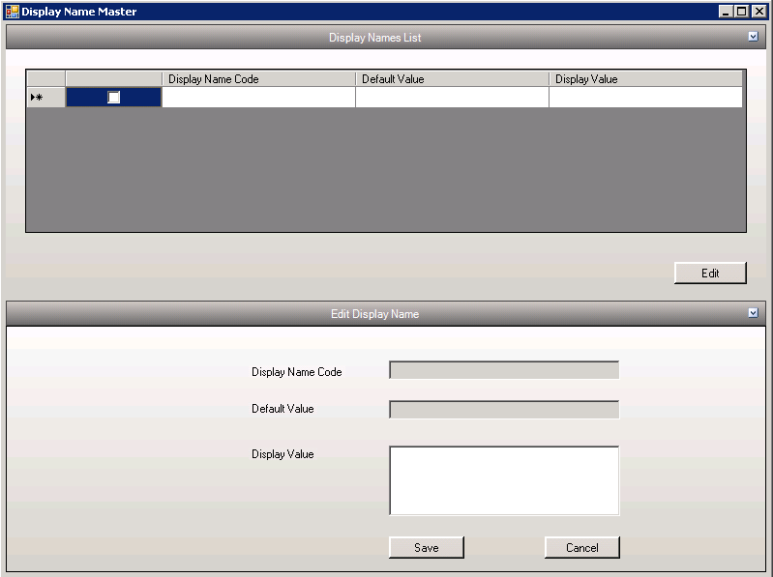

Editing the Display Value
- From the display names list the corresponding display name can be selected
- On click of “Edit” the options will open.
- Edit the display value and save by clicking “Save” button.

Tables affected:
- DisplayNameMaster

